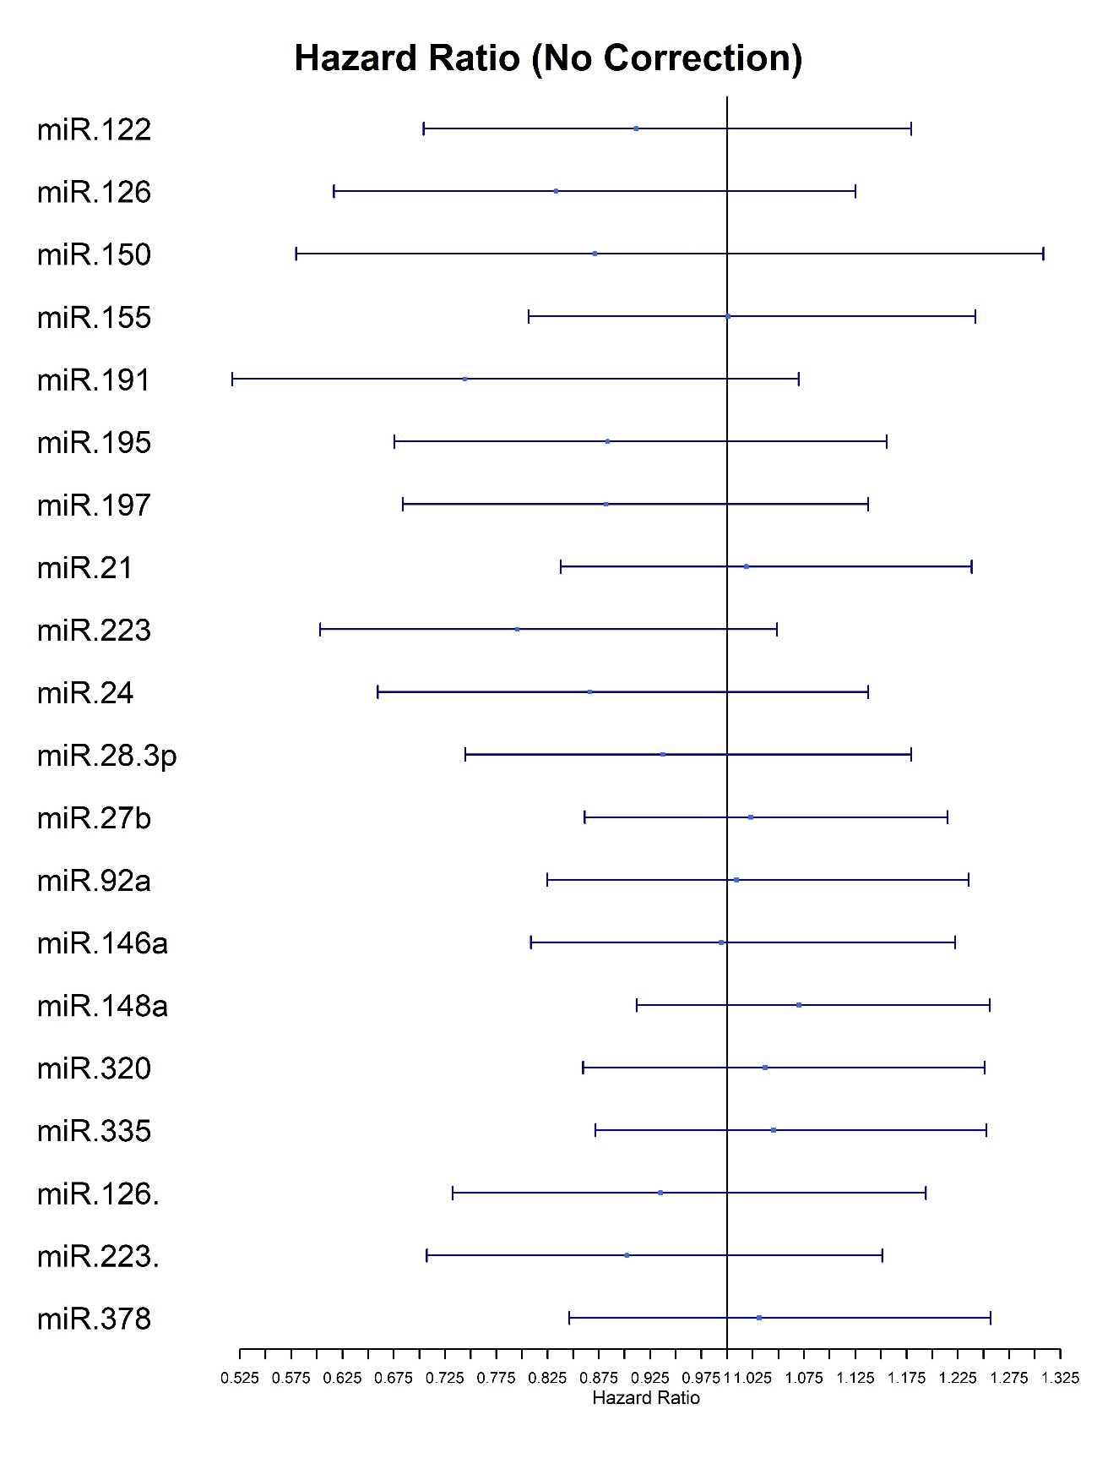

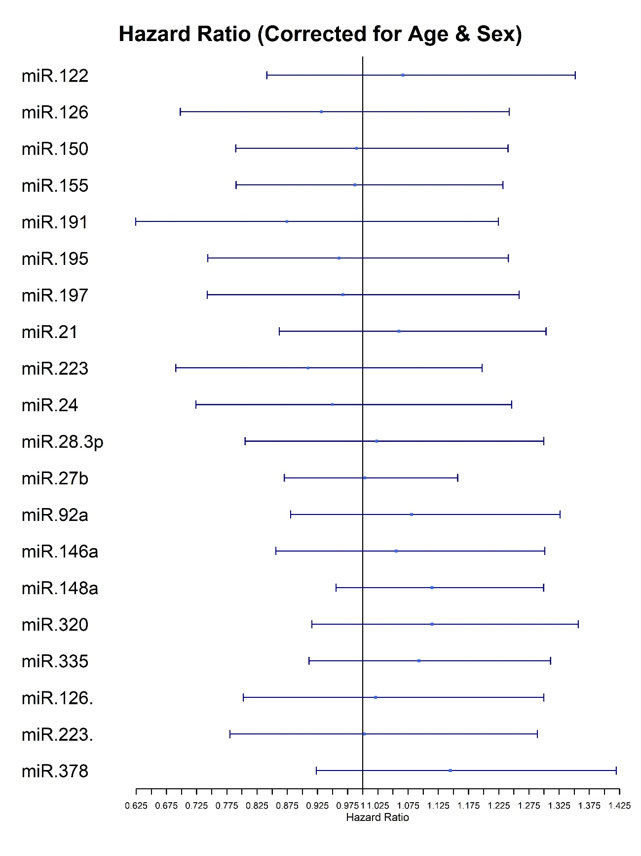

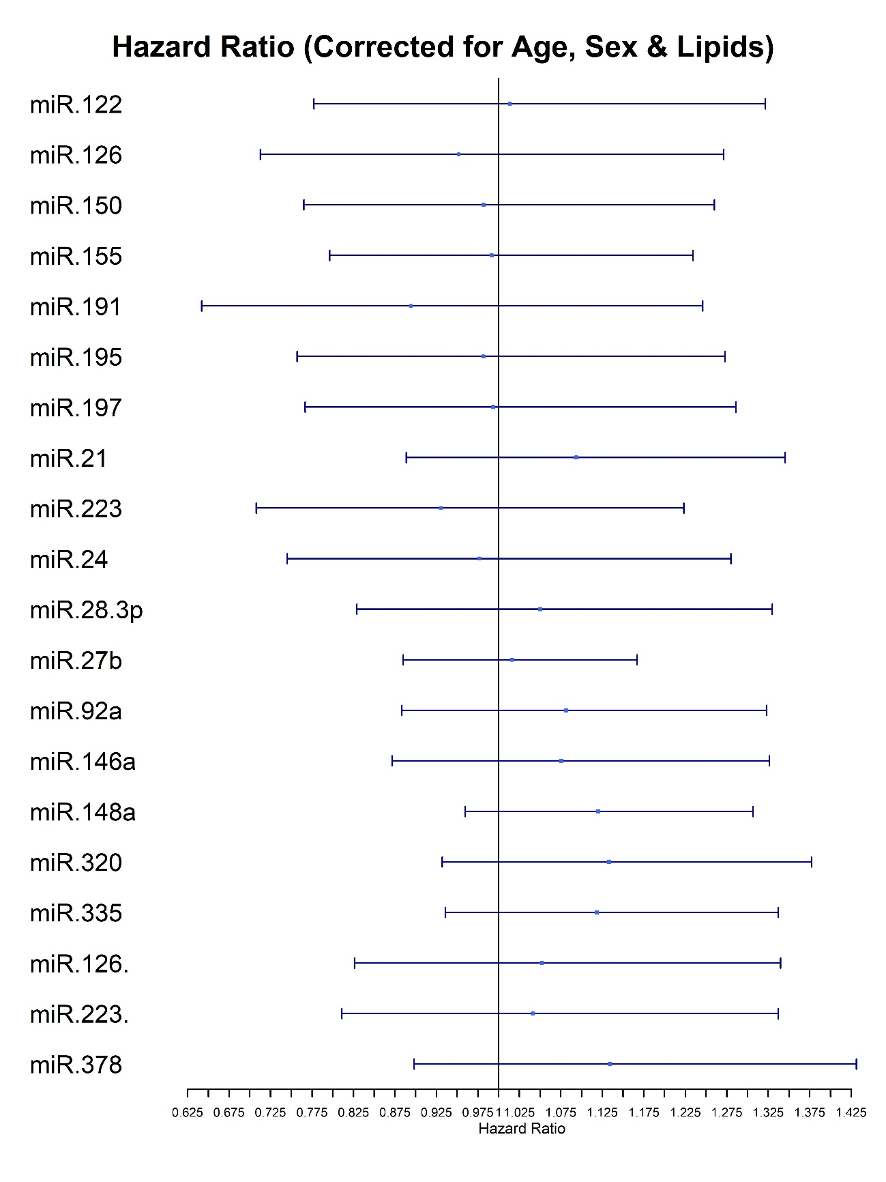

Supplementary Figure 7 – Hazard Ratio plots for Cox proportional-hazards regression analysis for miRNAs from Bruneck 2000 data, versus CVD event by 10-year follow-up data, with a) no correction, b) correction for age and sex, c) correction for age, sex, and lipids.